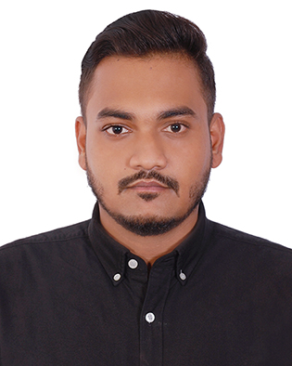
Tanvir Sohan

House: 953/1, East Shewrapara, Mirpur, Dhaka

tanvirewu2019@gmail.com  +8801676327074
+8801709222430

https://www.linkedin.com/in/tanvir-sohan-b38223134
––––––––––––––––––––––––––––––––––––––––––––––––––––––––––––––––––––––––––––––––––––––––––––––––
An enthusiastic learner opting to explore new aspects of organizational roles and excel in self-development through rigorous training. Undertakes complex assignments, meets tight deadlines and deliver superior performance. Operates with a strong sense of urgency and thrives in the fast paced setting.

Areas of Expertise:
________________________________________________________________________
▪ Biker (Licensed)  ▪ Branding Knowledge  ▪ Digital marketing  ▪ Communication | ▪ Quick Learning  ▪ Negotiation  ▪ Ms office  ▪ Tech Savvy
Club Experience:

- Brand Executive: East West University Sports Club (April 2015 – June 2019).
- Event Organizer & Designer: East West University Agro Industrialization Club (April 2015 – June 2018).
- Senior Lead Organizer: East West University 18th Convocation 2019 (30 February-2019).
- Head of project: Comilla Victoria Govt College Social Club (May 2011 – May 2012).
- Worked as a senior member at East West University Business Club (2015).
- Participated in a supply chain competition of promoting Creative Marketing Club (2017).
- Worked as a volunteer in winter cloths serving to poor & disable people in rural slum by Comilla Zilla School (2010, 2011).

Educational Background:

Bachelor of Business Administration (BBA)  (Major in Marketing)  2014-2019 | East West University | 2.23 out of 4.00 | 2019
HSC (Business Studies)  2010-2012 | Comilla Victoria Govt. College | 4.70 out of 5.00 | 2012
SSC (Business Studies)  2008-2010 | Comilla Zilla School, Comilla | 5.00 out of 5.00 | 2010

Job Experience:
- Worked as a Marketing Executive at Saimun Real Estate Ltd and Saimun Bricks Ltd. (From 15 January, 2018 to February 2019 ) (Part time) & (Sept 2019- April 2020) full time.
- Completed internship on Brand & Marketing at Link3 Technologies Ltd. (6th may to 7th august 2019)
- Worked as a Junior Digital Marketing trainee at Brand myth Digital agency. (Part time)
- Worked as a Sales Executive at Aarong. (Gulsan 1 outlet) (27thJune to 31 August 2016)
- Worked as a Call center Support executive at Cloudeaxis Ltd. (US Shift)

Managerial skills:
Gained managerial skills working as a Brand Coordinator at East West University Sports Club.
• Winter Smash 2017 • Winter Smash 2018 • Winter Smash 2019

References:
Md. Zahirul Islam  Deputy Manager, Brand & Marketing  Link3 Technologies ltd  Mobile: +88 01713073220  Tel: +88 02 9822288  IP PBX : +88 096789 01234  E-mail: zahirul.islam@link3.net | Mohammad Mamun  Head of HR  Saimun Real Estate Ltd.  1218,Kafrul,Mirpur,Dhaka  Mobile : +88 01712028451

I, the undersigned, hereby declare that all the above mentioned information is correct and will be responsible for any wrong information.


_______________
Tanvir Sohan

